Andrew Hampson

Feng Liu

Kuei-Yuan Chen

Po-Ying Yu

Date Submitted:

April 9, 2017

Group 10

**WEB APP**

**CONVERTIBILITY**



Project Template Report:

Converting a web app (footballplaybookonline.com) from ActionScript to JavaScript

*Table of Contents*

Project Title 1

Abstract and Summary 1~2

Objectives 2~3

Project Outcomes 3

Project Deliverables 3~5

Stage 1-5 3~5

Challenge Part 5

Prototype Diagram 6

Analysis 7

Research 8~9

The main research tools 8

The main research description 8~9

The main research link 9

Challenging and Risk 10

Project Schedule 10~14

Actual Effort Display 15~16

Contribution Report 16~17

Motivation 17~18

Client Detail 18

*PROJECT TITLE*

Converting a web app (footballplaybookonline.com) from ActionScript to JavaScript

*ABSTRACT/SUMMARY*

The Leffler software services project is trend to convert ActionScript Code to HTML5 and JavaScript and maintain existing functionality through utilize existing database and program calls.

Company hosts a website that provides services for designing football plays, storing plays, and sharing plays with other users. This website was developed by using ActionScript, XML, PHP, and MySQL. Some of the modern web browsers stop supporting ActionScript. The company has claimed that partial of his customers have encountered issues using the website, and all they can do is ask customers using web browsers that still support ActionScript such as Google Chrome. The web should be able to perform all functions which exist in original website successfully, and still retains old images, user data, and xml files in database from before.

Because current project course is embedded within a full time program, Group 10 has a limited period to work and limited time available for this project. The minimum scope is convert all playbook design functions from ActionScript and MXML to HTML5 and JavaScript. Ensure playbook design functionally (drag, drop, edit, add and move).

A few extra objectives are trying to work on if the minimum scope has been accomplished before the scheduled time. The list includes creating extra functions for premium users and adjusting the web site to have the ability to display different layout for mobile devices.

All of the code, which will use CreateJS tools and SVG, making it easy to contribute to the project.

Because ActionScript and Flash are being abandoned by the market, there is a large benefit to the client in refactoring the application to use JavaScript, even on the server-side. Most web browsers still support JavaScript, so the user experience will be improved or unchanged. In fact, a whole new segment of users will be available, because Android browsers never supported Flash Player. The client’s users will still enjoy the same service with the same accounts on an expanded platform.

*OBJECTIVES*

**Objectives**

Our objective in the Leffler Software services project will be based on function item be divided into 6 objectives.

* Research how to convert ActionScript to JavaScript.
* Analyze the whole App structure and the relationship between each script file.
* Find the script file related to each major function.
* Research the feasibility of the AS3JS Transpiler.
* Turn ActionScript design function to JavaScript  
  Prototype new design based on old app.
* Test functionality of design functions.

*PROJECT OUTCOMES*

* 1 working web app written in JavaScript and HTML.
* 16 Meeting Minutes,
* 1 Project Template Report,
* Gantt chart
* Evaluation Report
* Actual Effort Report

*PROJECT DELIVERABLES*

**Stage1 -------------------------------------------20% complete in total**

* Design Container------------------------------------------------------------20% complete

Container will hold graphical parts together in one place when displaying in the web

**stage2 --------------------------------------------40% complete in total**

* draw player object------------------------------------------------------------5% complete
* draw and add background image -------------------------------------------5% complete
* draw and add background Grid---------------------------------------------5% complete
* create editor bar -------------------------------------------------------------- 5% complete

drawing player Objects function related files converted to JS.

Drawing and adding background image related files converted to JavaScript.

Drawing and adding background grid related files converted to JavaScript.

Create editor bar related files converted to JavaScript.

**stage3 --------------------------------------------60% complete in total**

* Add objects------------------------------------------------------------------- 10%complete
* Delete objects---------------------------------------------------------------- 10%complete

Add object function will add objects to container for displaying

Delete object function will remove object from container

**stage4 --------------------------------------------75% complete in total**

* Drag and Drop---------------------------------------------------------------- 15%comlete

Adjust object position by mouse for dragging and dropping

**stage5 ------------------------------------------100% complete in total**

* Draw lines--------------------------------------------------------------------10% complete
* Draw curves------------------------------------------------------------------15% complete

Create draw lines function for connecting different objects in the container

Create draw curves function for connecting different objects in the container

**Challenge Part (beyond our scope): -----140% complete in total**

* Changing Properties ---------------------------------------------------------15%complete
* Real-time line drawing preview------------------------------------------- 15%complete
* Real-time curve drawing preview----------------------------------------- 10%complete

Changing properties will include color, rotation, size and name

Real-time line drawing preview will present the real-time display user is currently drawing the rectilinear figure

Real-time curve drawing preview will present the real-time display user is currently drawing the curvilinear figure

*PROTOTYPE DIAGRAM*

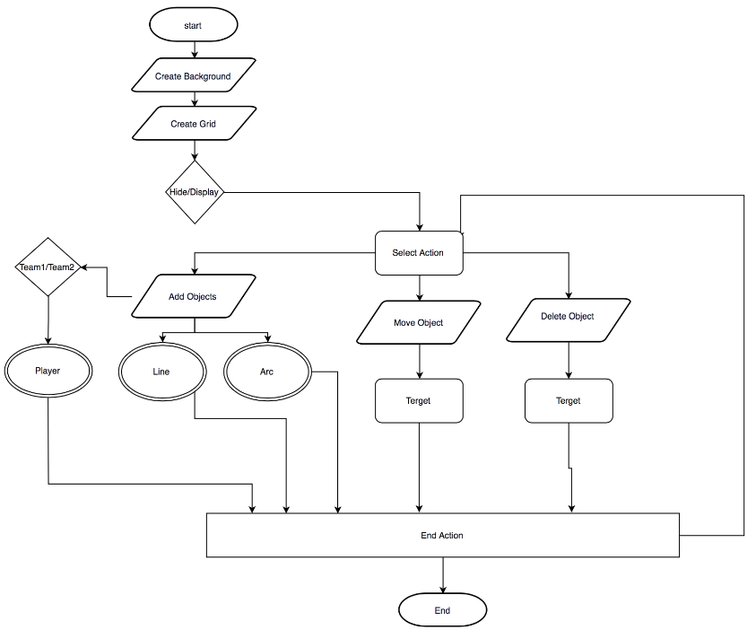

*ANALYSIS*

The Analysis will focus on the code understanding, whole app structure and the relationship between each script files

Function on the basis of each play folder:

* flashCode Folder

All single file (interface) will directly connect with web page and present the actual contents on the pages.

* pdfObjects Folder

Be responsibility to read the play that customer designed and convert it into pdf files that used for saving in the local disk.

* Playbook Folder

It is kind of a play container which present the function of each part of play

* GuiObject Folder

Basic draw method and component that allow customer to draw circle, curve, line, or other graphics based on their own customized design.

* Editor Folder

Be mainly charge of dealing with the menu bar function

Identify the next draw function that customer would like to achieve

*RESEARCH*

**The main research tools:**

* Code maintenance and online cooperation: GitHub
* IDE tools: NetBeans, IntelliJ,
* Text Editor: Notepad++, Atom
* ActionScript Transpilers: AS3JS, Adobe flash Professional CS6
* JavaScript syntax and method base: W3School, Stackoverflow, and CreateJs Doc

**The main research description:**

* Adobe flash CS6

Trying to add toolkit_for_CreateJS to convert ActionScript to javaScript;

Group member are trying to import source code- PlayViewer.as and Play.as first and then read the original code through using installed CreateJS toolkit to convert it to JavaScript.

* CreateJS-JavaScript Library

CreateJS is actually a tools which include many modular libraries, these libraries can work together to create interactive content on open web technologies via HTML5

Group member are trying to use CreateJS to rebuild ActionScript file-

The first thing is to select one of source code - background.as (focus on image rebuild and background grid) and create its JavaScript with the same function of ActionScript, then, testing whether or not the rebuilded JavaScript run efficiently and present completely on the webpages.

* NodeJS

It is very powerful JavaScript-based platform,

It includes many of basic modules are written in JavaScript.

Used to develop I/O intensive web application

* AS3JS

A Transpiler tool for converting ActionScript 3.0 to JavaScript.

It allows user to write both client and server-side JavaScript application using

the ActionScript 3.0 language.

* SVG

It stands for Scalable Vector Graphics

It defines the graphics in XML format

The element and attribute in SVG files can be animated

SVG graphics will not lose any quality if they are resized

**The main research link:**

* JavaScript Learning: w3School, Stackoverflow

<https://www.w3schools.com/>

<http://stackoverflow.com/questions>

* HTML5 & JavaScript create

<http://code.9leap.net/>

* Script Converter:  Node.js AS3JS

<https://as3js.org/>

* JS Library Support: CreateJS

<http://www.createjs.com/>

*CHALLENGING AND RISK*

* No Idea about flash

What the swf files is and how it works properly

* Confuse the concept of integration among XML, JS HTML and how to import html to database
* ASS3JS could not achieve the result we really want:

The team original preconception is to use AS3JS to covert most of syntax code, but some syntax doesn’t have library to support it. (For example: TitleWindow function in flash uses completely different mechanism from JS, there is no direct corresponding function in JS to implement TitleWindow function.)

So we plan to take two solutions to solve what we met

a), Create own library to the converted JavaScript file through researching or building the proper library, but it is hard.

b), Absolutely rebuild functionalities with JavaScript -  currently focus on, it is easy to test.

Basis on the above analysis, the project scope has been changed according to below reason.

a), Group members have no more experiences about ActionScript and its library is very hard to find

b), Team initial project is so broad that we could not handle as expected

c), Team’s initial plan did not provision time for design.

*PROJECT SCHEDULE*

[**Online Gantt Chart**](https://drive.google.com/file/d/0Bx6c_GoYLeb7ZVZBQ2k3V2N1WjA/view?usp=sharing)

The Gantt Chart would be updated though the project progress. Therefore, this is online Gantt Chart link which

**Gantt Chart link**

https://drive.google.com/file/d/0Bx6c_GoYLeb7OUVOcE9oMEctTlk/view?usp=sharing

**Overall Schedule Data flow**

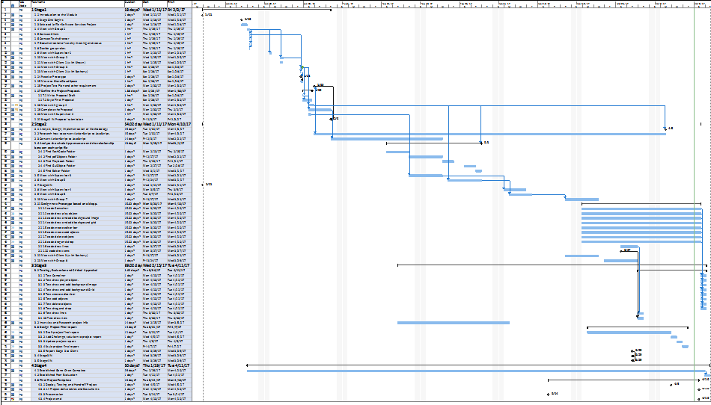

**Stage 1**

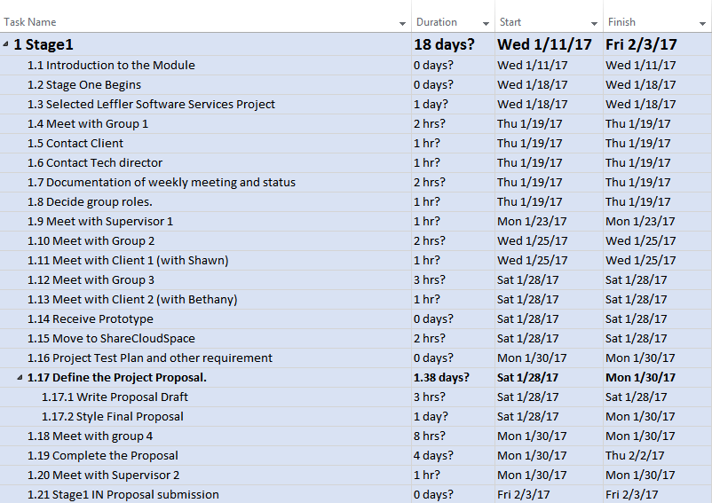

**Stage 2**

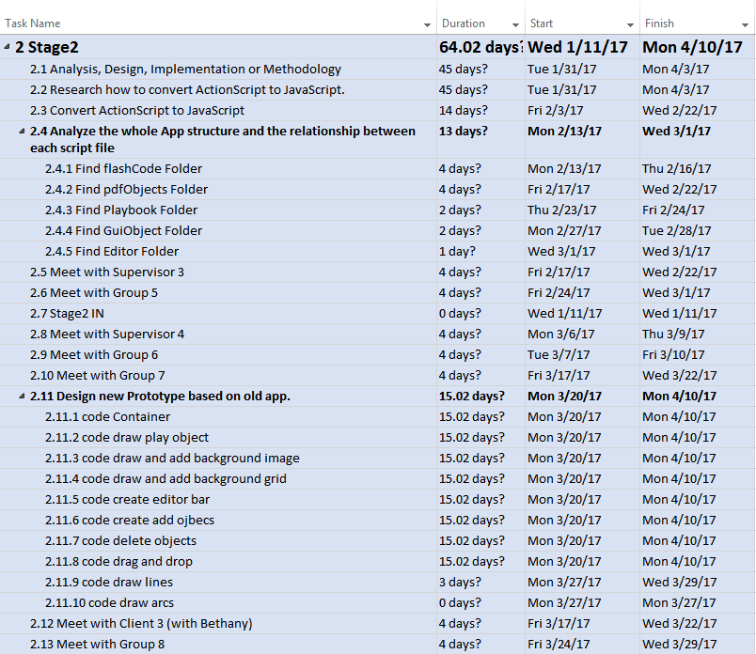

**Stage 3**

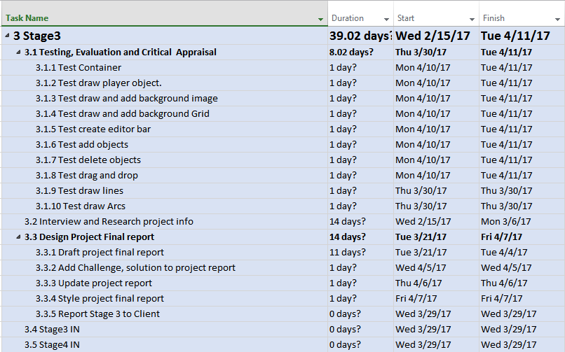

**Stage 4**

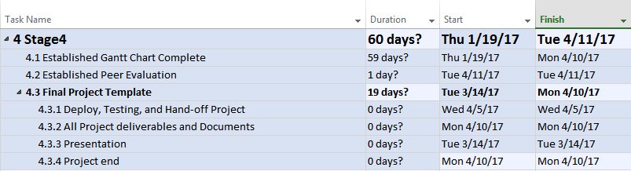

ACTUAL EFFORT DISPLAY

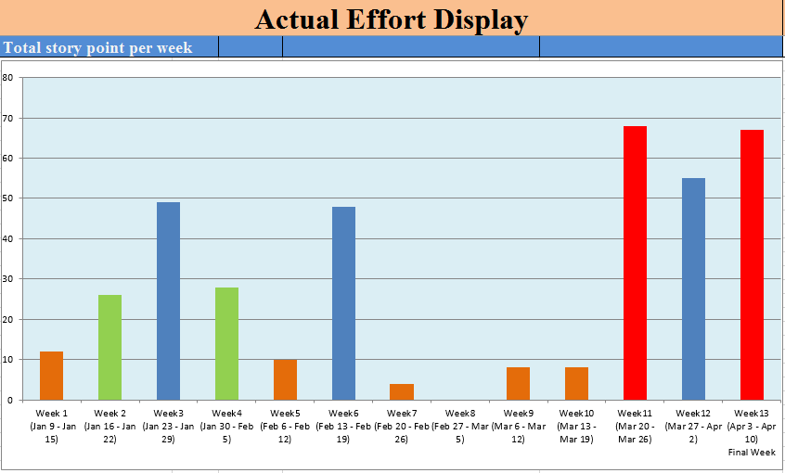

The bar chart gives information about how many story point the ACIT 3900 group 10 achieved in the Web App Convertibility project, over 13 weeks’ period between January 10th and April 10th in 2017.

Overall, it can be seen that the entire period could be divided into 3 parts, week1 to week 6, week 7 to week 10 and week 11 to week 13,

Looking at the detail, the story point in Part 3 that group 10 spend is the highest in all three parts, which is over 60 points definitely every week. Due to the final presentation is coming soon, all project documentation, live demo, source codes have to be ready to submit and present, so the story point in this part is much higher than others;

Conversely, the points in Part 2 just be focused on over 5 points each week. The most likely reason is that this three week is at front and behind midterm, the member of group who put more attention on their middle term exam in order to make them review all course and get good grade. So the time they spend on 3900 project would be relatively reduced.

The average story points in part 1 is approximately 25 points per week, that is the normal status of progress as they expected. In this part, group member start to contact client to learn the project requirement, plan week meeting, research the project related knowledge and prepare proposal.

PERCENTAGE OF EFFORT

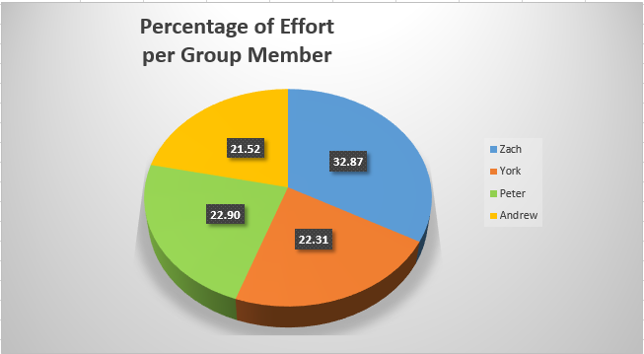

This pie chart shows how many percentage of effort each member from group 10 contribute in 3900 project.

Here is the role for each group member:

**Zach**: Coding, Project Manager---------------------------------------------------------------------32.87%

**York**: Documentation, Research data--------------------------------------------------------------22.31%

**Peter**: Coding, Data Analysis------------------------------------------------------------------------22.90%

**Andrew**: Coding, Data Analysis--------------------------------------------------------------------21.52%

*MOTIVATION*

* Flash is dead now. However, there is a lot of good flash website running outside. If we can use this opportunity to learn how to transfer the old website to new pop format. We think that it is a lot of work in the IT industry.
* This is the first time; we can face the real challenge from a real client. We need to clearly understand what we can do, what client needs, then find the balance between each wishes. Also, we learned a lot skills of team working, communication, and project managements. We hope that we can use all of what we learned in the past on this project to prove myself.
* Our strongest motivation is that we are more close our future career, and we want to join IT industry immediately.
* In term4 study, there is a course called Integrative programming and Technologies which teach me how to represent structure and how to transport data using XML and XML related technologies and protocol. Through this project, we could take this good opportunity to deep understand how the programming integrated and what useful tools could control the integration function.
* Time management is a good factor to get success under entire project, during this project, I will have change to define task, organize meeting so that every specific mission could be achieved by each team member on time, in addition, the realization of self-confidence and self-worth will get improvement via practicing.
* We have a little touch on Java, JS, PHP, HTML, SQL, and CSS. We think it’s time to applied this knowledge and see how these skills combine with real world project.
* As mobile devices become more popular, we think it could be an interesting project to make a mobile friendly responsive web design.

*CLIENT DETAILS*

**Bethany Edmunds: Tech support**

* Technical questions regarding project development.
* Provide all of the existing code (such as ActionScript) and answer any questions about how the current software works.

**Shawn Leffler: our main client**

* He is located in East Coast, so the client meeting will happen through phone call or Skype.
* All of our documents should go through Shawn.
* Shawn may not join every meeting because of the other project he has to be involved in. He will join the meeting at the end of each specific stage.